MATRIX
THE MATRIX IS A SEMESTER LONG ASSIGNMENT YOU WILL WORK ON WHEN YOU HAVE FREE TIME. THE MATRIX WILL BE DUE AT THE END OF SEMESTER 1 WITH THE FINAL. IF IT IS NOT FINISHED IN CLASS THEN IT IS HOMEWORK.
Step 1: Fill the entire paper with a 2"x2'' grid. (front and back)
Step 2: On the back come up with 3 positive/ negative designs. (could be your initials) The design must touch all four sides of the box.
 | 1 | 2 | 3
 | HZ | ❖ | ZH

Step 3: Pick one to trace in the 2''x2'' boxes. Flipping to create the mirror image. This will create rhythm because we are repeating our pattern.
Step 4: Color with one light and one dark color. Alternating between the positive and negative shapes.
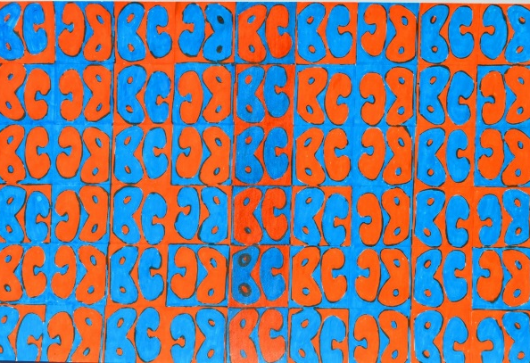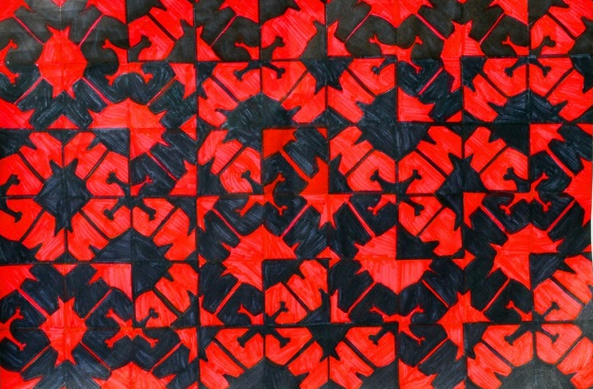
Step 5: On the back write your name, period number and make a list of all the elements and principles you can identify.
Space, line, shape, value, form, color, texture, emphasis, movement, pattern, balance, rhythm, unity

