NAME _________________________________________________Per:________
Literal qualities: does the artwork imitate life?
Design qualities: is the artwork organized?
Expressive qualities - does the artwork evoke and emotion?
Artwork | Image | Do you think this is art? (Yes or No) Why? (Design, literal or expressive or ALL THREE?)
Leo Twiggs, The Blue Wall (page 29) | 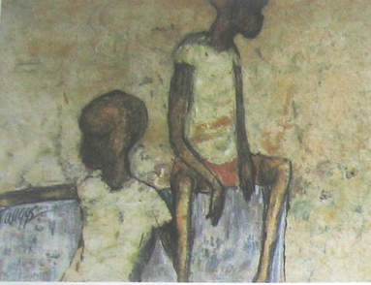
Constantin Brancusi, The Kiss (page 104) | 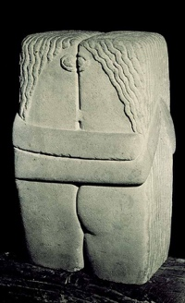
Hans Holbein, Anne of Cleves ( page 9) | 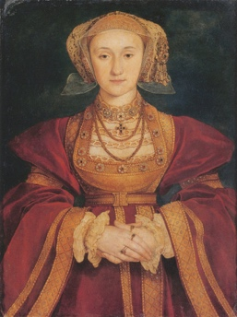
Larry Poons, Orange Crush (page 379) | 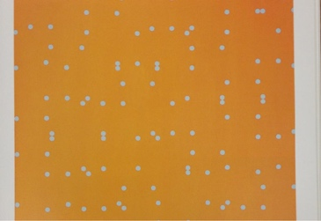
Henri Matisse, Purple Robe (page 24) | 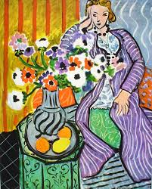
Pablo Picasso The old guitarist (page 270) | 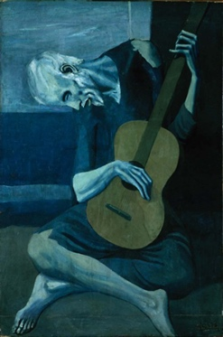
Leo Twiggs, Single Family Blues (page 269) | 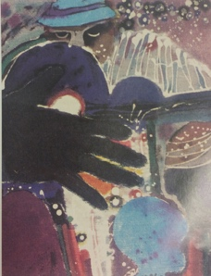
Rie Munoz, Both the sun and Moon belong to women (page 252) | 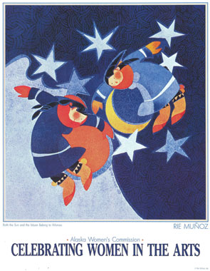
Frida Kahlo, Self Portrait (page 239) | 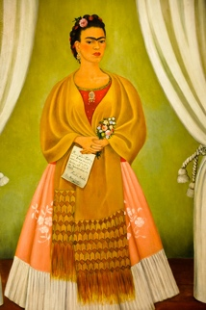
Louise Nevelson, Dawn (page 300) | 