ART CRITIQUE

1)Describe the Subject: Make a list of all the things you see in the artwork.
2) Analyze the Composition: How does line, space, color, form, value, shape create movement, emphasis, variety, balance, pattern, rhythm? Refer to your elements and principles handout in your portfolio.
3) Your Interpretation of the content: What do you think the artist trying to communicate?
4)Your Judgement: Now ask, is this a successful work of art? Do you like it? Is it art? Why? Does it have design qualities? literal qualities? Or expressive qualities?
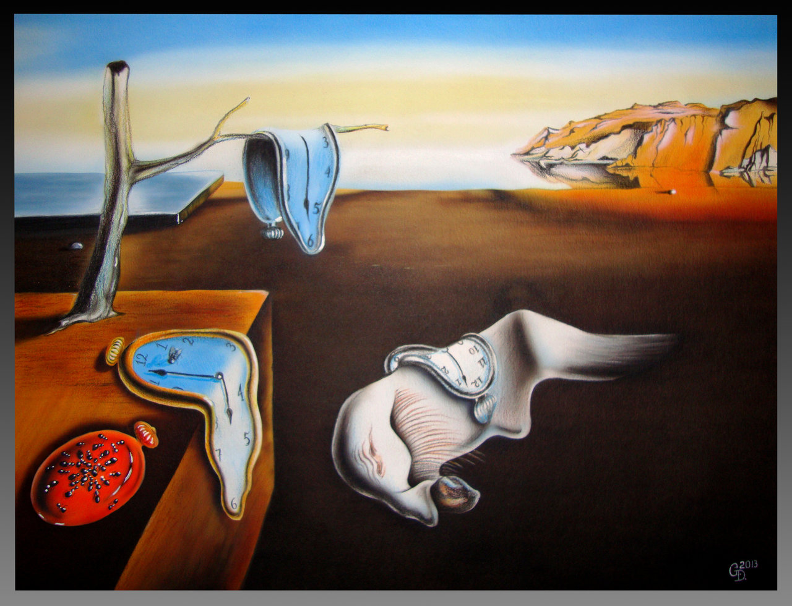

Salvador Dali , “Persistence of a Memory”, 1931, Oil on Canvas, 9 ½’’ x 13" (24.1 x 33 cm), Museum of Modern Art, New York City

